National University of Computer and Emerging Sciences



Assignment 05

Artificial Intelligence

|  |  |
| --- | --- |
| Name | Muhammad Abdullah  Mohammad Abdullah Faisal |
| Roll No. | 19F-0111  19F-0128 |
| Section | CS-6A |
| Instructor | Dr. Hashim Yasin |

**Part A:**

**Question#1:**

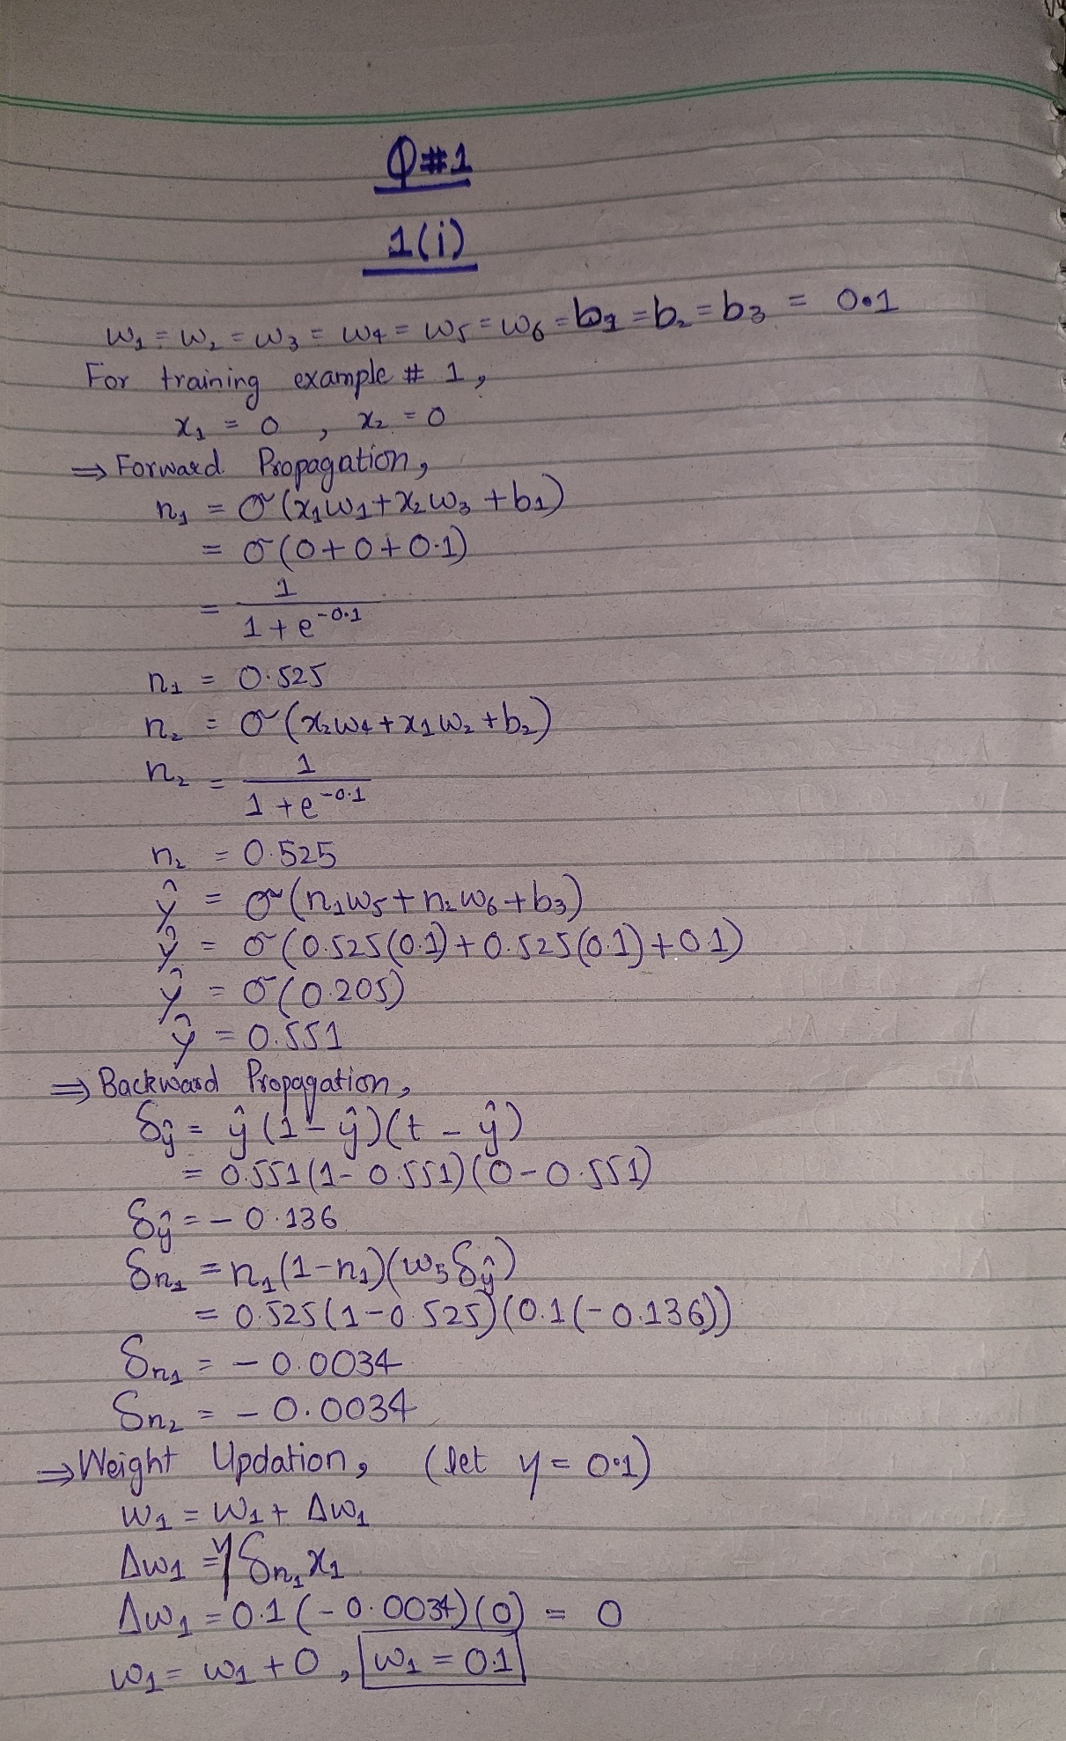

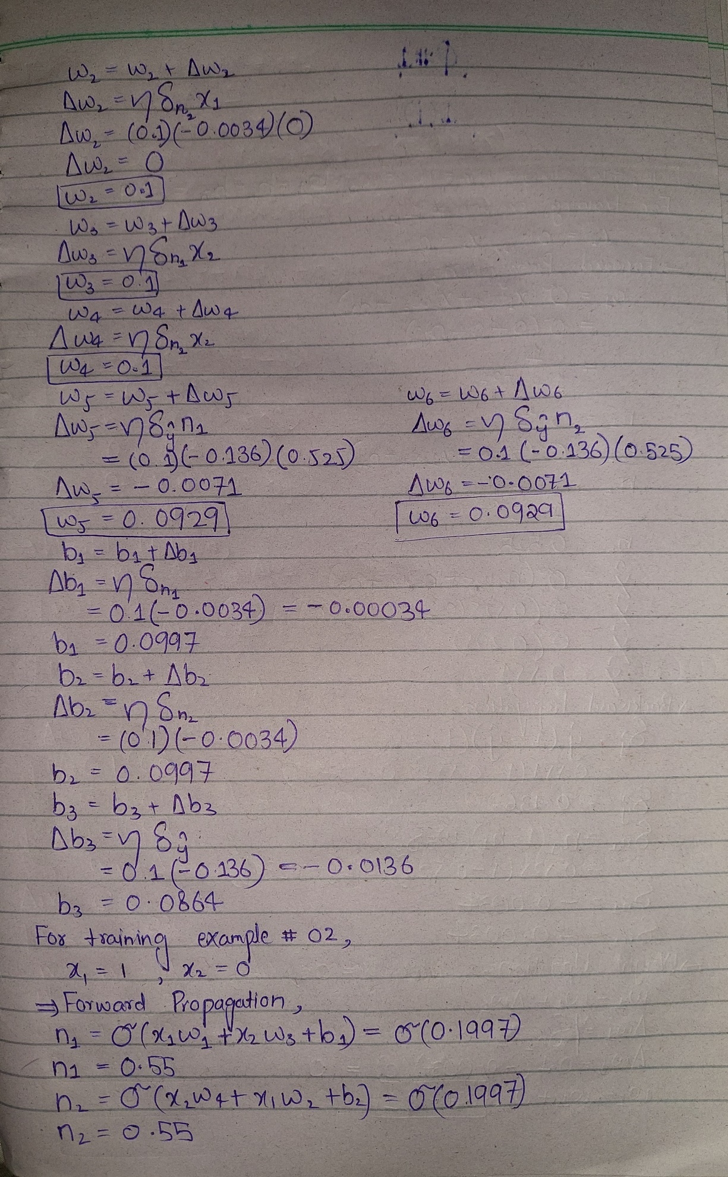

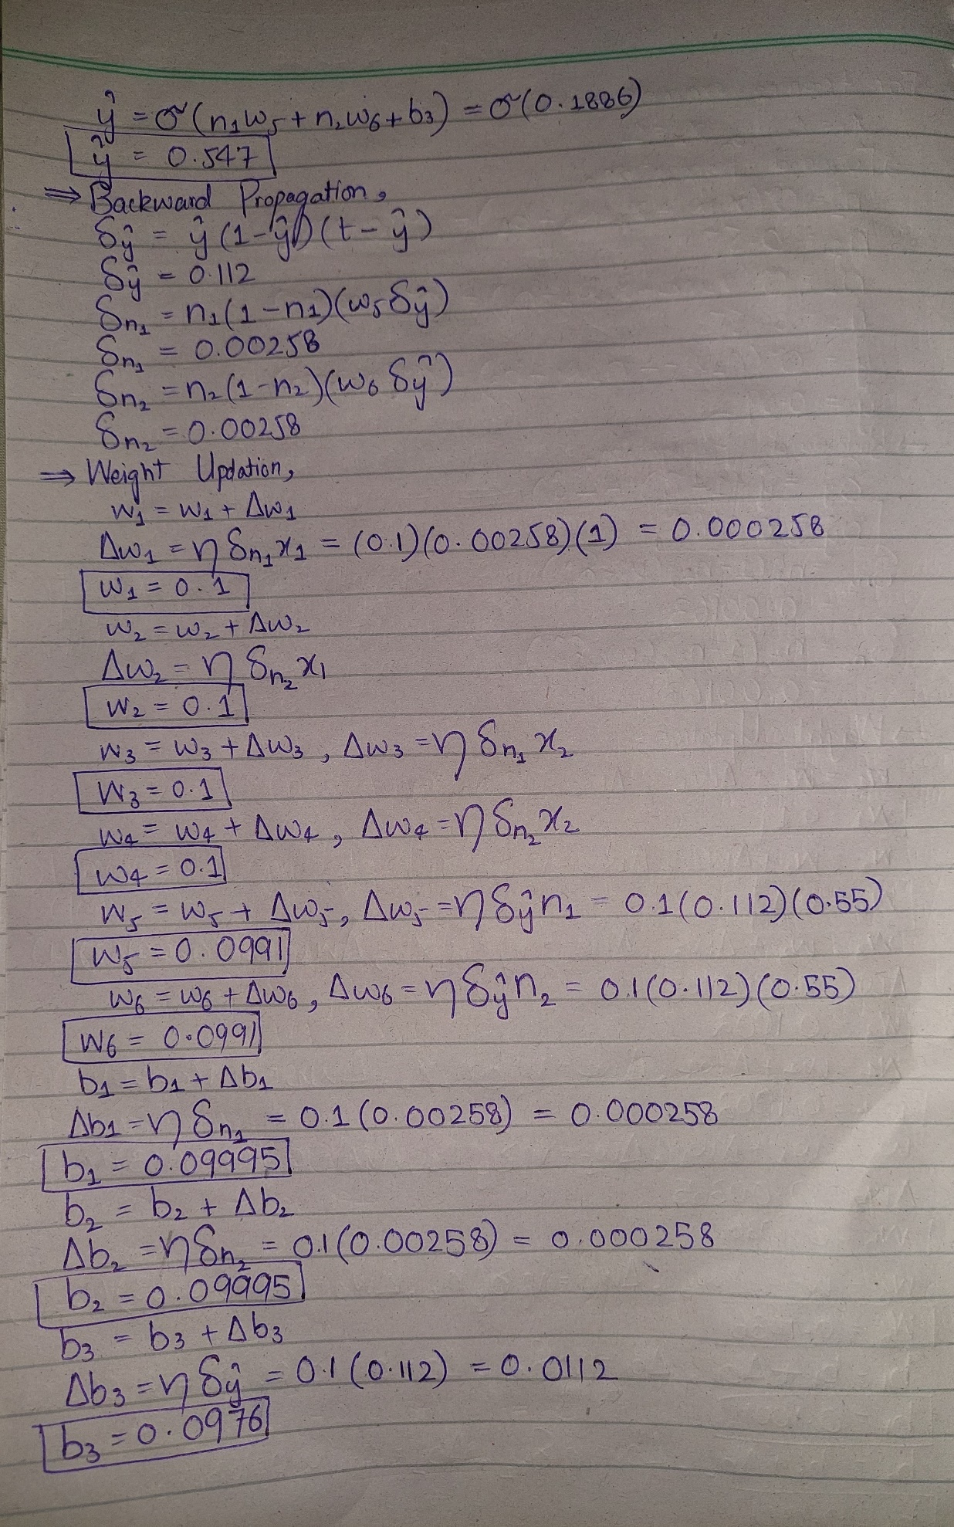

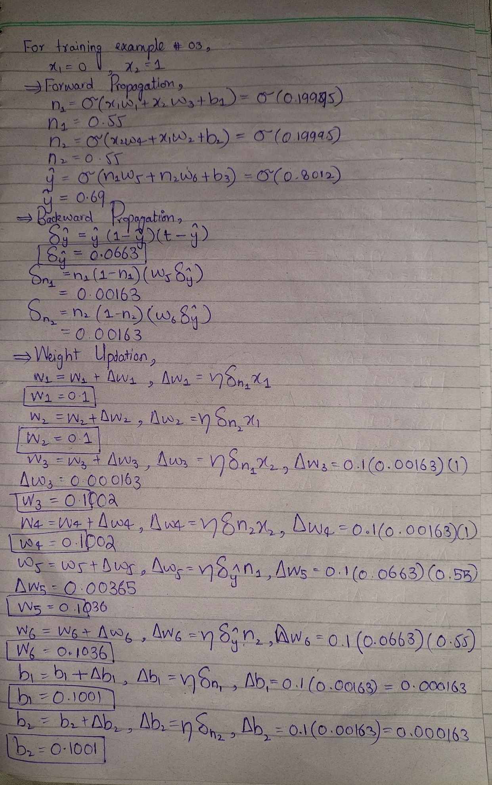

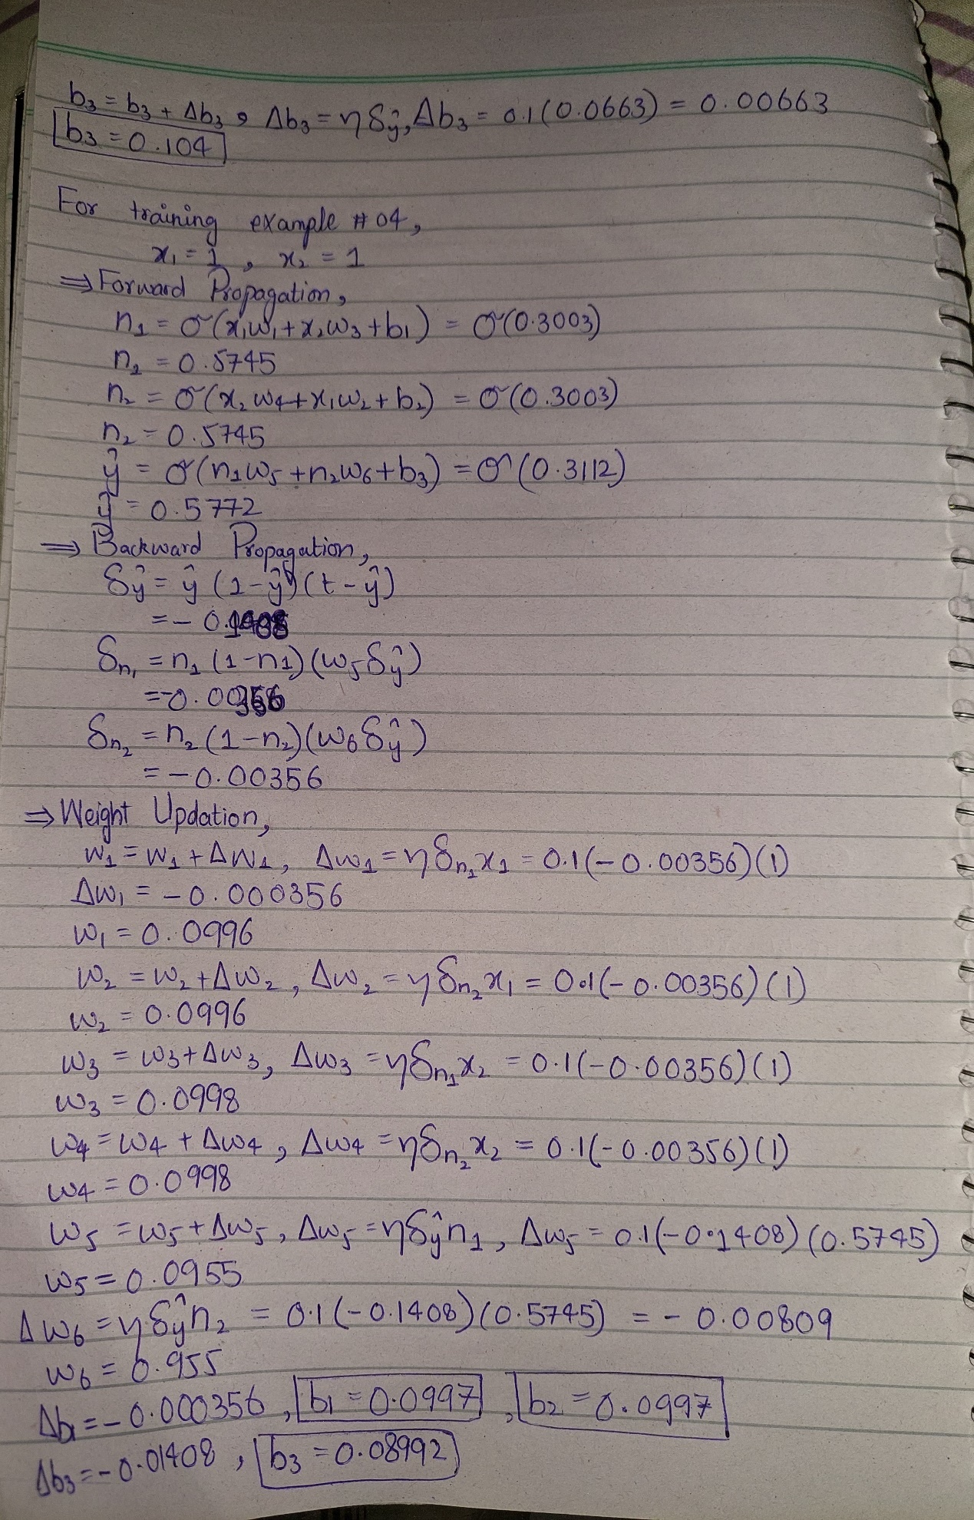

**Question#2:**









**Part B:**

import numpy as np  
  
operator = 'and'  
# ----------------  
atributes = np.array([[0, 0], [0, 1], [1, 0], [1, 1]])  
# ----------------  
  
labels=[]  
for i in range(len(atributes)):  
 labels.append(atributes[i][0]*atributes[i][1])  
  
w = [+9, +9] # initial random values for weights  
  
threshold = 5  
alpha = 0.5 # learning rate  
epoch = 1000 # learning time  
# ----------------  
  
global_delta = 100 # this variable is used to terminate the for loop if learning completed in early epoch  
for i in range(0, epoch):  
 print ("Iteration number: ",i)  
 fire = None  
 once=True  
 for j in range(len(atributes)):  
 actual = labels[j]  
 if(j>=global_delta and once):  
 global_delta=0  
 break  
 print("Actual Value: ",actual,end="")  
 # calculate sum  
 sum=atributes[j][0]*w[0]+atributes[j][1]*w[1]  
 # condition to then fire  
 if(sum>threshold):  
 fire=1  
 # condition to do not fire  
 else:  
 fire=0  
 print(", Predicted Value: ",fire)  
 # calculate the error  
 error=actual-fire  
 # update weights with respect to the error  
 # calulate global delta  
 if(error != 0):  
 global_delta=j  
 once=False  
 w[0]=w[0]+alpha*error  
 w[1]=w[1]+alpha*error  
 print("Value of w1: ",w[0]," Value of w2: ",w[1])  
  
 if global_delta == 0:  
 break  
 print("------------------------------")  
  
print("\n------------------------------")  
print("Final Weights are: ",w[0],' ',w[1])  
print("------------------------------\n")

**Display:**

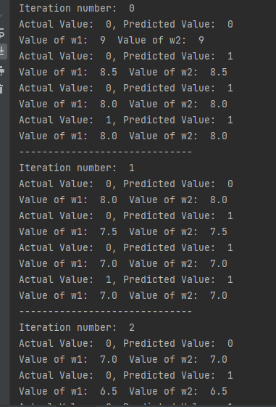

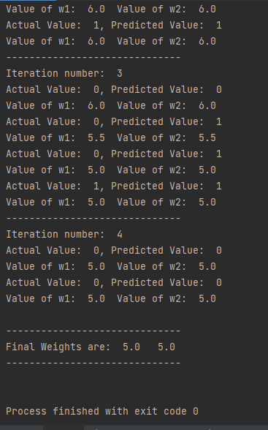**s**